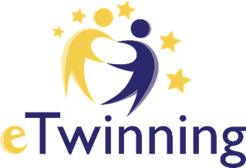

W.A.T.E.R
We Are The Ecology Readers!

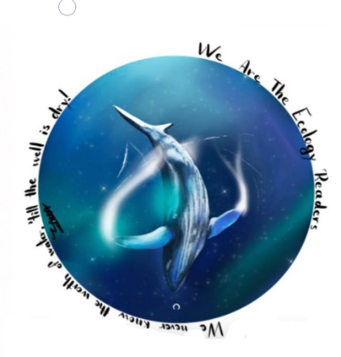

What’s Our Aim?
We are working on a project about water saving. The project process has started in January 2021 and it will be completed by the end of May 2021. There are ten different schools that we are collaborating with. Partners are from Turkey, Spain,Serbia and Romania,which includes 100 students and 15 teachers.
During the project, collaboration, sharing ideas, learning from each other is essential. We are carrying out considering eSafety and internet ethics. We will use Web 2 tools and technology in all project process. We will make evaluation and dissemination end of the project.

By Duru & Erva
KAL-1

PROJECT POSTER
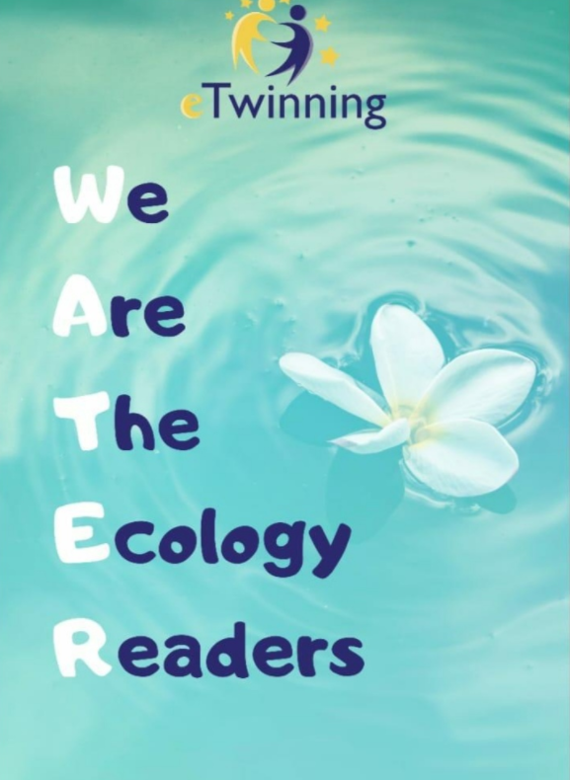
( Poster created by Ece from KAL-2 Team. And elected first in the voting as a Project Poster)

